**SQL PRIMARY KEY: How to Create & Add to Existing Table**

**What is Primary Key in SQL?**

**Primary Key**is a field or a combination of fields that identify a record uniquely. The Primary key is a column or set of columns that are unique. In other words, every value is unique for Primary Key.

**Rules for Primary Key**

* Each table can have only one SQL Primary Key.
* All the values are unique and Primary key SQL value can uniquely identify each row.
* The system will not allow inserting a row with SQL Server Primary Key which already exists in the table.
* Primary Key cannot be NULL.

Below diagram summarizes all the above point for the SQL Primary Key.

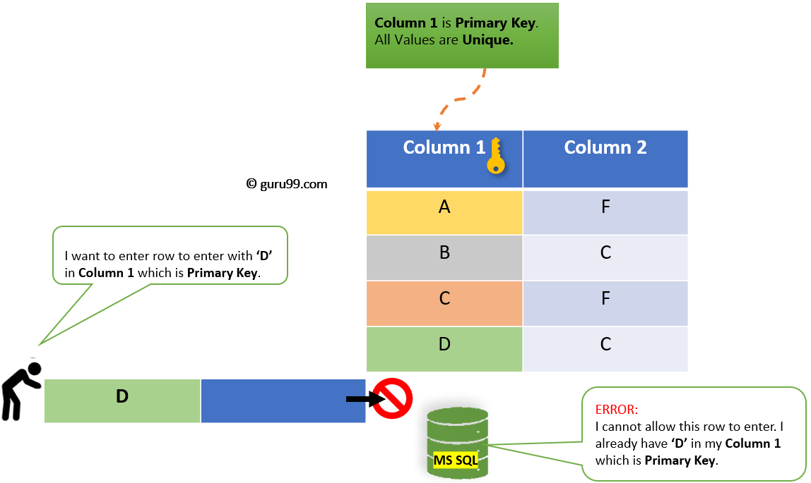How Primary Key SQL Works

**How to Create Primary Key in SQL Server**

We can Create a Primary Key in **2 ways:**

1. [SQL Server Management Studio](https://www.guru99.com/sql-server-management-studio.html)

2. T-SQL: Create Primary while creating a New Table

### SQL Server Management Studio

**Step 1)**Right Click on the Table name. Click on **Design.**

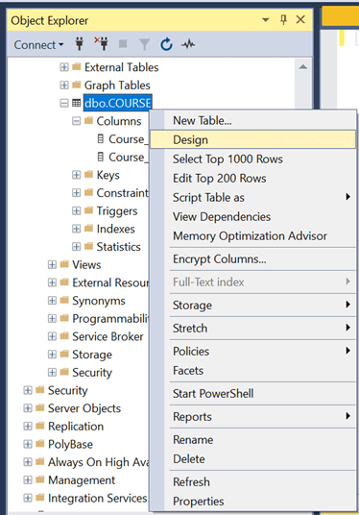

**Step 2)**Right-click on the Column name. Click on '**Set Primary Key'**

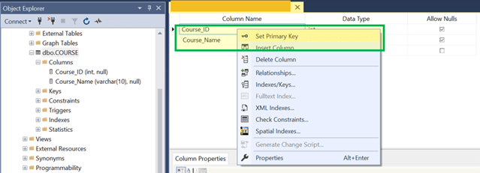

**Result:**Course_Id is now a**Primary Key.**

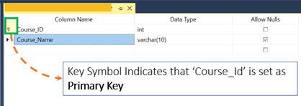

### T-SQL: Create a Primary key while creating a New Table.

Below is the syntax to create table with Primary Key from T-SQL

**Syntax:**

CREATE TABLE <Table_Name>

(

Column1 datatype,

Column2 datatype,CONSTRAINT <Name> PRIMARY KEY (Column name)

.

);

Let's create a Table with One Column as a SQL Primary Key.

**Query:**

CREATE TABLE COURSE_TSQL_PK

(Course_ID Int not Null,

Course_name Varchar(20)

CONSTRAINT PK PRIMARY KEY (Course_ID)

)

**Step 1)** Run the Query by clicking on **'Execute.'**

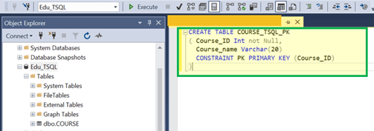

**Result:**Course_Id is now a**Primary Key.**

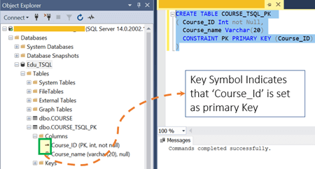

**Example:**Let's see if it allows entering Multiple Records with Same Course ID.

**Step 1)** Insert 4 rows with **different Course_ID**

Insert into COURSE_TSQL_PK values (1,'SQL');

Insert into COURSE_TSQL_PK values (2,'Python');

Insert into COURSE_TSQL_PK values (3,'SQL');

Insert into COURSE_TSQL_PK values (4,'C');

**Step 2)** Verify all Data Inserted successfully by running the Select query.

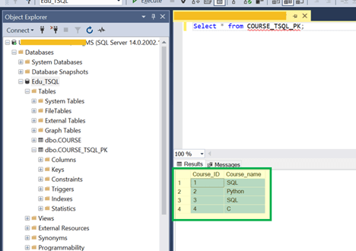

**Note**: We can insert duplicate values in the Non-Primary key.

**Step 3)** Now let's try Inserting New records with an existing Course_ID which is Primary Key.

Insert into COURSE_TSQL_PK values (4,'JAVA');

**Result:**System does not allow inserting new value as 4 is there Course_ID column which is a Primary Key.

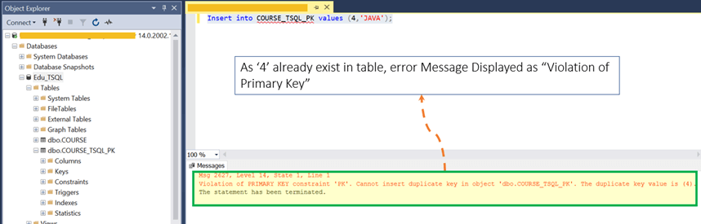

### T-SQL: Add a Primary key to existing table using Alter Table

Now we will see how to add Primary Key to existing table in SQL:

You can use the ALTER statement to create a primary key. However, the primary key can only be created on columns that are defined as NOT NULL. You cannot create a primary key on a column that allows NULLs. If you need to do, you have to drop and recreate the table.

Here is the syntax:

ALTER TABLE tableName

ADD CONSTRAINT constraintName PRIMARY KEY (column_1, column_2, ... column_n);

For example:

ALTER TABLE students

ADD CONSTRAINT students_pk PRIMARY KEY (admission);

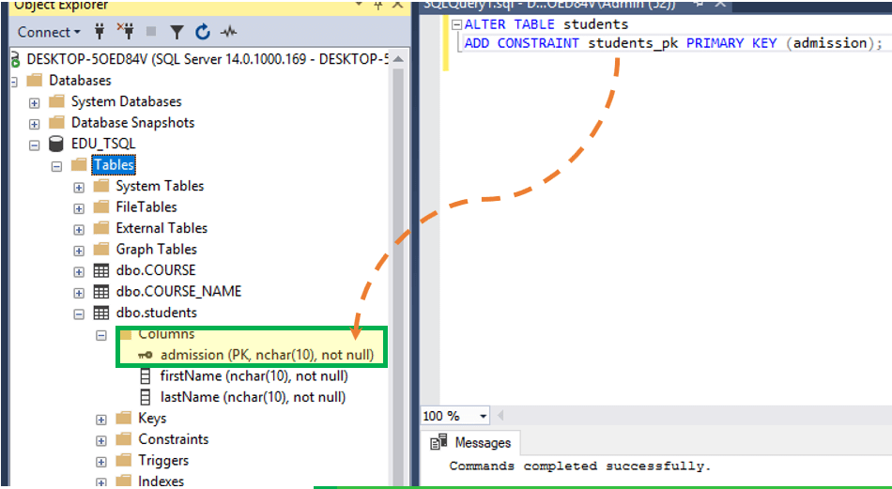

We have added a primary key constraint to an already existing table. The constraint has been added on the admission column and assigned the name students_pk.